**Lab 8: Exercise Physiology**

I. Introduction

II. General Methods

III. Bicycle Ergometer or Steps

IV. Treadmill

Worksheet at end of lab

**I. INTRODUCTION**

**Note:  None of the exercises in this laboratory should be performed if you are sick.  If you feel dizzy, pain, or unwell at any time during the exercise, stop immediately**.

**Please bring appropriate workout clothes (shorts or sweatpants, T-shirt, sneakers)**.

In this laboratory you will measure how the body responds to endurance exercise by performing a series of measurements under resting conditions, at a low intensity, and at a moderate intensity.  Several of these measurements we have performed in the previous lab including blood pressure and heart rate.  One new parameter we will measure is the body's rate of oxygen consumption (VO2).  Under resting conditions, the muscles in the body consume very little oxygen, and therefore we are measuring other energy requiring systems active at rest (i.e. maintenance of ion gradients, protein synthesis, and circulation of blood).  Yet during maximal exercise, oxygen consumption can be 10 times higher due to the intense oxygen demands of the muscles.

The questions you will address in this lab are:

1. How does oxygen consumption change from rest to exercise?

2. Does the percentage of carbohydrate and fat oxidized vary with intensity of exercise?

3. How does the cardiovascular system respond to the stress of exercise?

METABOLIC RATE

Cells require energy to function even when the body is at rest.  This energy is derived from food through a series of chemical transformations.  All the chemical changes that take place in an organism constitute its metabolism.

An individual's metabolism, or metabolic rate, can be divided into three major components.

1. The basal metabolic rate (BMR), which encompasses all the tasks needed to keep the body alive (see below).
2. The metabolism associated with activity (thermal effect of activity).  For example, if a person goes from sitting to walking, the muscles use more oxygen, the heart has to beat faster to deliver that oxygen, and respiration increases to supply that oxygen.
3. Energy associated with the digestion of food.

The basal metabolic rate (BMR) is the minimum amount of metabolism necessary to perform a number of different tasks including:

* Synthetic/degradative chemical reactions
* Generating/maintaining ion gradients
* Signal conduction
* Mechanical work of respiration
* Circulation of blood
* Maintenance of body temperature

Measurements of Metabolic Rate

All energy output from the body eventually appears as heat from the body.  Therefore, one way to determine metabolic rate is to measure the amount of heat given off by a person in the basal state.  This requires complicated equipment that is not available in this lab.  Instead, a simpler method, which estimates metabolic rate from oxygen consumption, will be used.

The link between heat and oxygen consumption can be illustrated through the oxidation of glucose (carbohydrate).  If glucose is burned, the following reaction occurs:

(glucose) C6Hl2O6 + 6O2 🡪 6CO2 + 6H2O + heat

Thus, like wood in a fire, food requires oxygen in order to be transformed and release its energy.

The oxygen consumed by the body can be determined with a few simple measurements and assumptions.  First, it is important to know that the air in the atmosphere is 20.93% oxygen, 0.03% carbon dioxide and 79% nitrogen.  Nitrogen is biologically inert meaning that the volume of nitrogen that we breathe in will be the same that we breathe back out.  Therefore, by measuring the percent of oxygen and carbon dioxide expired along with the volume of air inspired it is possible to determine the amount of oxygen consumed (VO2) and the amount of CO2 produced (VCO2).   This measurement can be performed with a one-way breathing mouthpiece (expired air is not re-breathed).  This mouthpiece has internal valves, which allow air to flow in only one direction.  Therefore, when air that is breathed in from the atmosphere is exhaled, it goes to a separate collecting chamber where the volume of air and percentage of oxygen can be determined.

Calories, Fats and Carbohydrates

Energy is often measured in Calories, a unit familiar to most people from the values listed on food products.  Since we can equate oxygen consumption to heat production we can use oxygen consumption to determine how many calories an individual burns at rest.  Not only can we determine how many Calories a person burns at rest, but we can also determine what percentage of those Calories come from fats and what percentage comes from carbohydrates.  This calculation is possible because carbohydrates and fats each have different innate oxygen contents. Therefore, based on the relative amount of oxygen consumed and carbon dioxide produced it is possible to determine how much of a person's energy use is coming from fats or carbohydrates.  The ratio of VCO2/VO2 is referred to as the respiratory exchange ratio (RER).  A value of 0.7 indicates that energy use is coming entirely from fats, a ratio of 1.0 indicates that a subject is using 100% carbohydrates, and a ratio of 0.85 indicates a subject is using an equal amount of carbohydrates and fat.

Oxygen Consumption During Exercise

When an individual begins exercising, the rhythmic contraction of the muscles requires energy.  This energy demand is met mostly through the consumption of oxygen during oxidative phosphorylation.  Yet to deliver the oxygen to the muscles a series of steps must occur.  Figure 1 shows the major steps during oxygen consumption:

1. Oxygen is taken in through the lungs

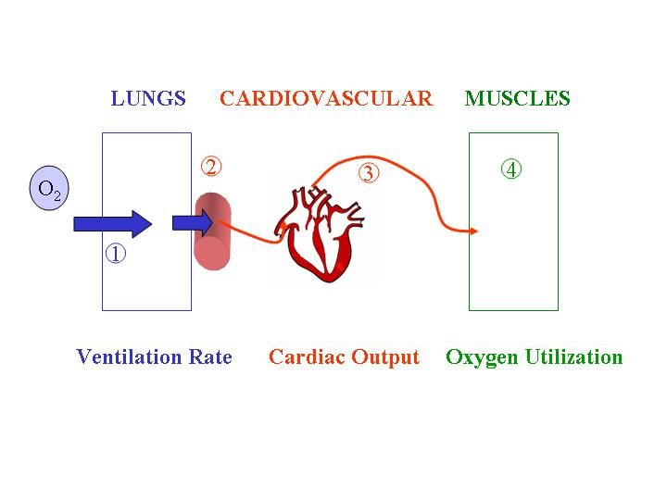

Fig. 1 Major steps during oxygen consumption

1. Oxygen diffuses into the blood stream where it combines with hemoglobin
2. The heart pumps the hemoglobin (oxygen) through the circulation to the various tissues of the body.
3. Oxygen diffuses into the different tissues of the body where it is used by the mitochondria to make ATP.

Thus the ability of the body to consume oxygen depends on:

* ventilation rate
* hemoglobin content
* cardiac output (stroke volume x heart rate)
* oxygen uptake by the tissues

Therefore, during exercise an increase in oxygen consumption is accompanied by changes in multiple physiological variables.

**II. GENERAL METHODS**

Each group will get data from the bicycle/steps experiment and the treadmill experiment. The hard part will be distributing the groups among the limited equipment. If you are in a small group, consider splitting up and joining other groups. If you find yourself with nothing to do while you wait for equipment, then get to work on the worksheet and start analyzing your data from the first experiment. If it’s towards the end of the lab and you still haven’t completed the treadmill experiment, then work with another group and use their data. We have to be patient and flexible in this lab.

The general role for each of the four students in a group will be:

* One person is the subject
* One person measures blood pressure, changes workload on the bike/treadmill
* One person records data (HR, BP, Respiration Rate, workload)
* One person works on the computer with Labscribe

There are two stations that you will rotate through in this laboratory exercise. Be patient as you wait for equipment.

* Bicycle Ergometer (x1) or Steps (x2)
* Treadmill (x2)

How to use heart rate monitors

* **The strap must be wet before applying to the chest.** The strap should fit snugly; if it is too big, then try a different subject, or tie knots in the strap to make it smaller.
* **The watch needs to be in EXE mode to function.** Press the button until you see EXE in the display. The subject does not need to have the wrist monitor around his/her wrist.  The observer can hold the wrist monitor.
* **The heart rate symbol flashes until the heart rate is found.** While the monitor is searching for your heart beat, there could be interference from other nearby monitors. Try going into the hallway to get it started. Once it has found your heart rate, then other sensors nearby will not affect your readings.

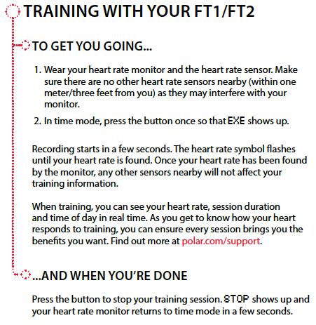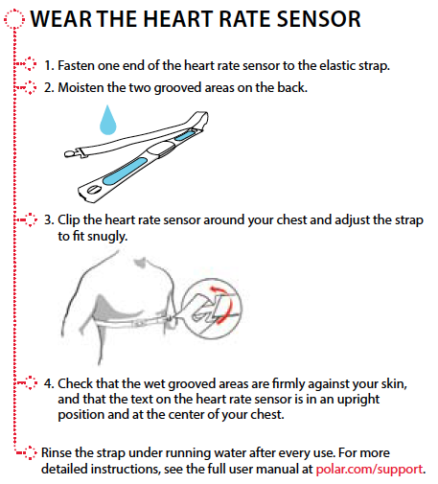

If you really cannot get your heart rate monitor to work on anyone in your group, you can always measure heart rate manually by feeling the pulse in a large artery in the neck or arm. The automatic blood pressure cuffs also measure heart rate, so that is another option. You can also use your own heart rate monitor if you have one.

**III. BICYCLE ERGOMETER OR STEPS**

**a) Background**

The bicycle ergometer (ergo = work, meter = measure) is slightly different than a standard bicycle because it allows you to adjust the pedaling resistance to a known value (on a regular bike you would have to cycle up a hill to increase the resistance).  The ability to control resistance on the ergometer allows you to determine your power output (power = work/time).

To determine power output on the bicycle ergometer, two different parameters can be adjusted:

1. Resistance force in kiloponds (kp).  This can be adjusted by tightening or loosening the black plastic screw between a range of 0-7.  The value of the resistance is determined by the pendulum located near the front wheel.  Once you start pedaling, the pendulum might swing.  If you use your hands to prevent the pendulum from swinging, you can get it to stabilize near the correct value for the resistance.
2. Pedaling rate in revolutions per minute (RPM).  This is adjusted by changing your pedaling cadence and monitoring RPM on the speedometer.

The power you produce by pedaling on the bike is analogous to the power used by light bulbs (power is measured in watts).  Therefore, if you are cycling at 120 watts you are producing enough power to light up two 60 watt light bulbs.  Professional cyclists in the Tour de France can maintain a power output of 300-400 watts for about an hour, and can peak near 600 watts.

If the bicycle is not available, you can do this same experiment using the steps. You will need to figure out a good speed to step up and down the step so it is light exercise vs moderate exercise. This will vary depending on the subject, so test it out before continuing with the step exercise.

**b) Experiment**

1. Prepare your subject by fitting a heart rate monitor around their chest.  It is best for the experimenter to hold the wrist monitor.  Read the earlier directions about how to properly use the heart monitors.

2. Place a blood pressure cuff around the arm, but not inflated.  It is helpful to put a ring of tape around the cuff to keep it in place.

3. Before your subject starts exercising measure their resting heart rate and blood pressure and enter these values in Table 3 in the worksheet.

4. Find a resistance on the bike that you think that you can reasonably handle when pedaling at 60 RPM for 5 minutes.  Aim for a resistance that will give you a heart rate around 150 beats per minute. This will be your moderate resistance. Typically values of resistance are 1-3 kp, but this will depend on your level of fitness.

5. Once you have found a resistance that results in a heart rate around 150 BPM take this resistance and divide it in two to get your light resistance.  For example, if you had a heart rate around 150 BPM with a resistance of 2kp, then your light resistance would be 1kp.

6. If you are using the steps, then try to figure out the speed of stepping that results in a heart rate of 150 bpm for the moderate exercise.

7. Set the resistance on the bike to the light resistance and begin pedaling at 60 RPM.  It is very important that you maintain your cadence at 60RPM.  Either increasing or decreasing your cadence will change your power output. If you are using the steps, then step up and down at the speed you determined for light exercise.

8. When you begin cycling at this light resistance you will need to measure heart rate every 30 seconds for the first 2 minutes and then every minute for a total of 5 minutes.  During minute 4-5 measure and record the blood pressure.  Enter data in **Table 1** in the worksheet.

9. Blood pressure can be difficult to measure while a subject is exercising because of the extra noise and body movement.  When taking blood pressures on a bike, the subject should grab the elbow of the person taking the blood pressure, and the person taking the blood pressure should grab the elbow of the subject.  Therefore, the subject and BP person are "shaking elbows" instead of shaking hands.  For the steps, you may need to wait until right after the person stops stepping to take the blood pressure.

10. Once your blood pressure has been measured you can stop cycling, yet you need to continue to record the heart rate every 30 seconds for 2 minutes while the subject sits on the bike, and then every minute for a total of 5 minutes. If your heart rate reaches a steady baseline earlier, you can stop recording. Make sure you take the blood pressure 5 minutes after exercise.

11. Repeat the same procedure (HR, BP) by cycling for five minutes at your predetermined moderate resistance. Enter data in **Table 2** in worksheet.

**c) Data Analysis**

During the bicycling exercise the following parameters were directly measured:

1. Heart rate
2. Blood pressure (Ps/Pd)

You will need to calculate the following parameters:

1. Stroke Volume (SV)
2. Cardiac Output (CO)
3. Total peripheral resistance (TPR)

Enter the data and calculations in **Table 3**. For the resting measurements use the data you collected before exercise. For light and moderate exercise enter the heart rate and blood pressure determined at 5 minutes and use this for the calculations.

During the post exercise period, note what happened to the heart rate. Why is that? When did the fastest drop in heart rate occur? If you recover very quickly after exercise, then that means you are physically fit and your cardiovascular system is in “good shape”.

We will use the Lab 8 Jupyter notebook to calculate the following parameters. Follow the directions in the notebook to generate the values for Table 3. You can either print out the table and include it in your worksheet or you can write them in by hand. You don’t need to submit the Jupyter notebook to bCourses this time.

Stroke Volume and Cardiac Output

To calculate stroke volume (S.V.) and cardiac output (C.O.) we can use the formula described in the Physiological Measurements laboratory exercise:

S.V. (ml/beat) = 1.7 (ml/mm Hg) x (Ps-Pd)

C.O. (ml/min) = S.V. x H.R.

C.O. (ml/min) = 1.7 x (Ps – Pd) x H.R.

Ps: systolic pressure (mm Hg)

Pd: diastolic pressure (mm Hg)

H.R.: heart rate (beats/min)

S.V.: stroke volume (ml/beat)

C.O.: cardiac output (ml/min)

Total Peripheral Resistance

To calculate total peripheral resistance, we can use the formula described in the Physiological Measurements laboratory exercise:

T.P.R. = MAP / C.O.

MAP = 1/3 (Ps - Pd) + Pd

T.P.R.: total peripheral resistance

MAP: mean arterial pressure

C.O.: cardiac output

Ps: systolic pressure

Pd: diastolic pressure

If C.O. is in ml/sec then T.P.R. is in (mm Hg x sec)/ml which is 1 peripheral resistance units (P.R.U.).  The minimum resistance of the circulation can be about 0.2 P.R.U when all the blood vessels are maximally dilated. The maximum resistance of the circulation can be about 4 P.R.U., when all the blood vessels are maximally constricted.

Bike Power Output

To determine the power output in watts when cycling at 60 RPM, multiply your resistance in Kp by 60.  For example, if you cycled at 1.5 kps your power output would be 90 watts. If you were doing the step exercise, then you can skip this calculation.

**IV. TREADMILL**

The treadmill exercise takes longer than the bicycle experiment, but you can help speed things up by knowing what you are doing before you start, and by doing all the calculations later away from the computer. Lab groups may need to work together for this experiment and share data.

* NOTE: **do not load the settings** (it is already open), because an important calibration has been done that will be lost if you reload the settings file. Do not turn off LabScribe at any point during this experiment. (If for any reason LabScribe needs to be restarted, make sure you are using software version 3.6 and let your GSI know the program restarted).

**a) Treadmill parameters**

There are two basic parameters that can be adjusted with the treadmill:

1. Elevation: can be adjusted by pressing either the up or down triangles

2. Speed: can be adjusted by pressing either the faster or slower triangles

We will only be running at a moderate pace (~9-10 min/mile) in this lab, but for comparisons the best marathon runners average about 4:45/mile (men) and 5:20/mile (women) for over 26 miles.

The following 8 parameters will be measured in this exercise. How to obtain these parameters is detailed below in the data analysis section.

1. Heart rate (measured with a heart rate monitor)
2. % O2, % CO2, respiration rate (measured using Labscribe recorded data)
3. VO2, VCO2, RER, and Ve (calculated using Labscribe)

**b) Experiment**

Once you start recording in LabScribe, keep it recording until Step 7.

1. **Record data for 20 secs with mouthpiece on the table and the chamber open.** Data should show %O2 and %CO2 for room air (about 21% and 0.04%). The %CO2 value may rise throughout the lab period as expired CO2 builds up in the chamber.

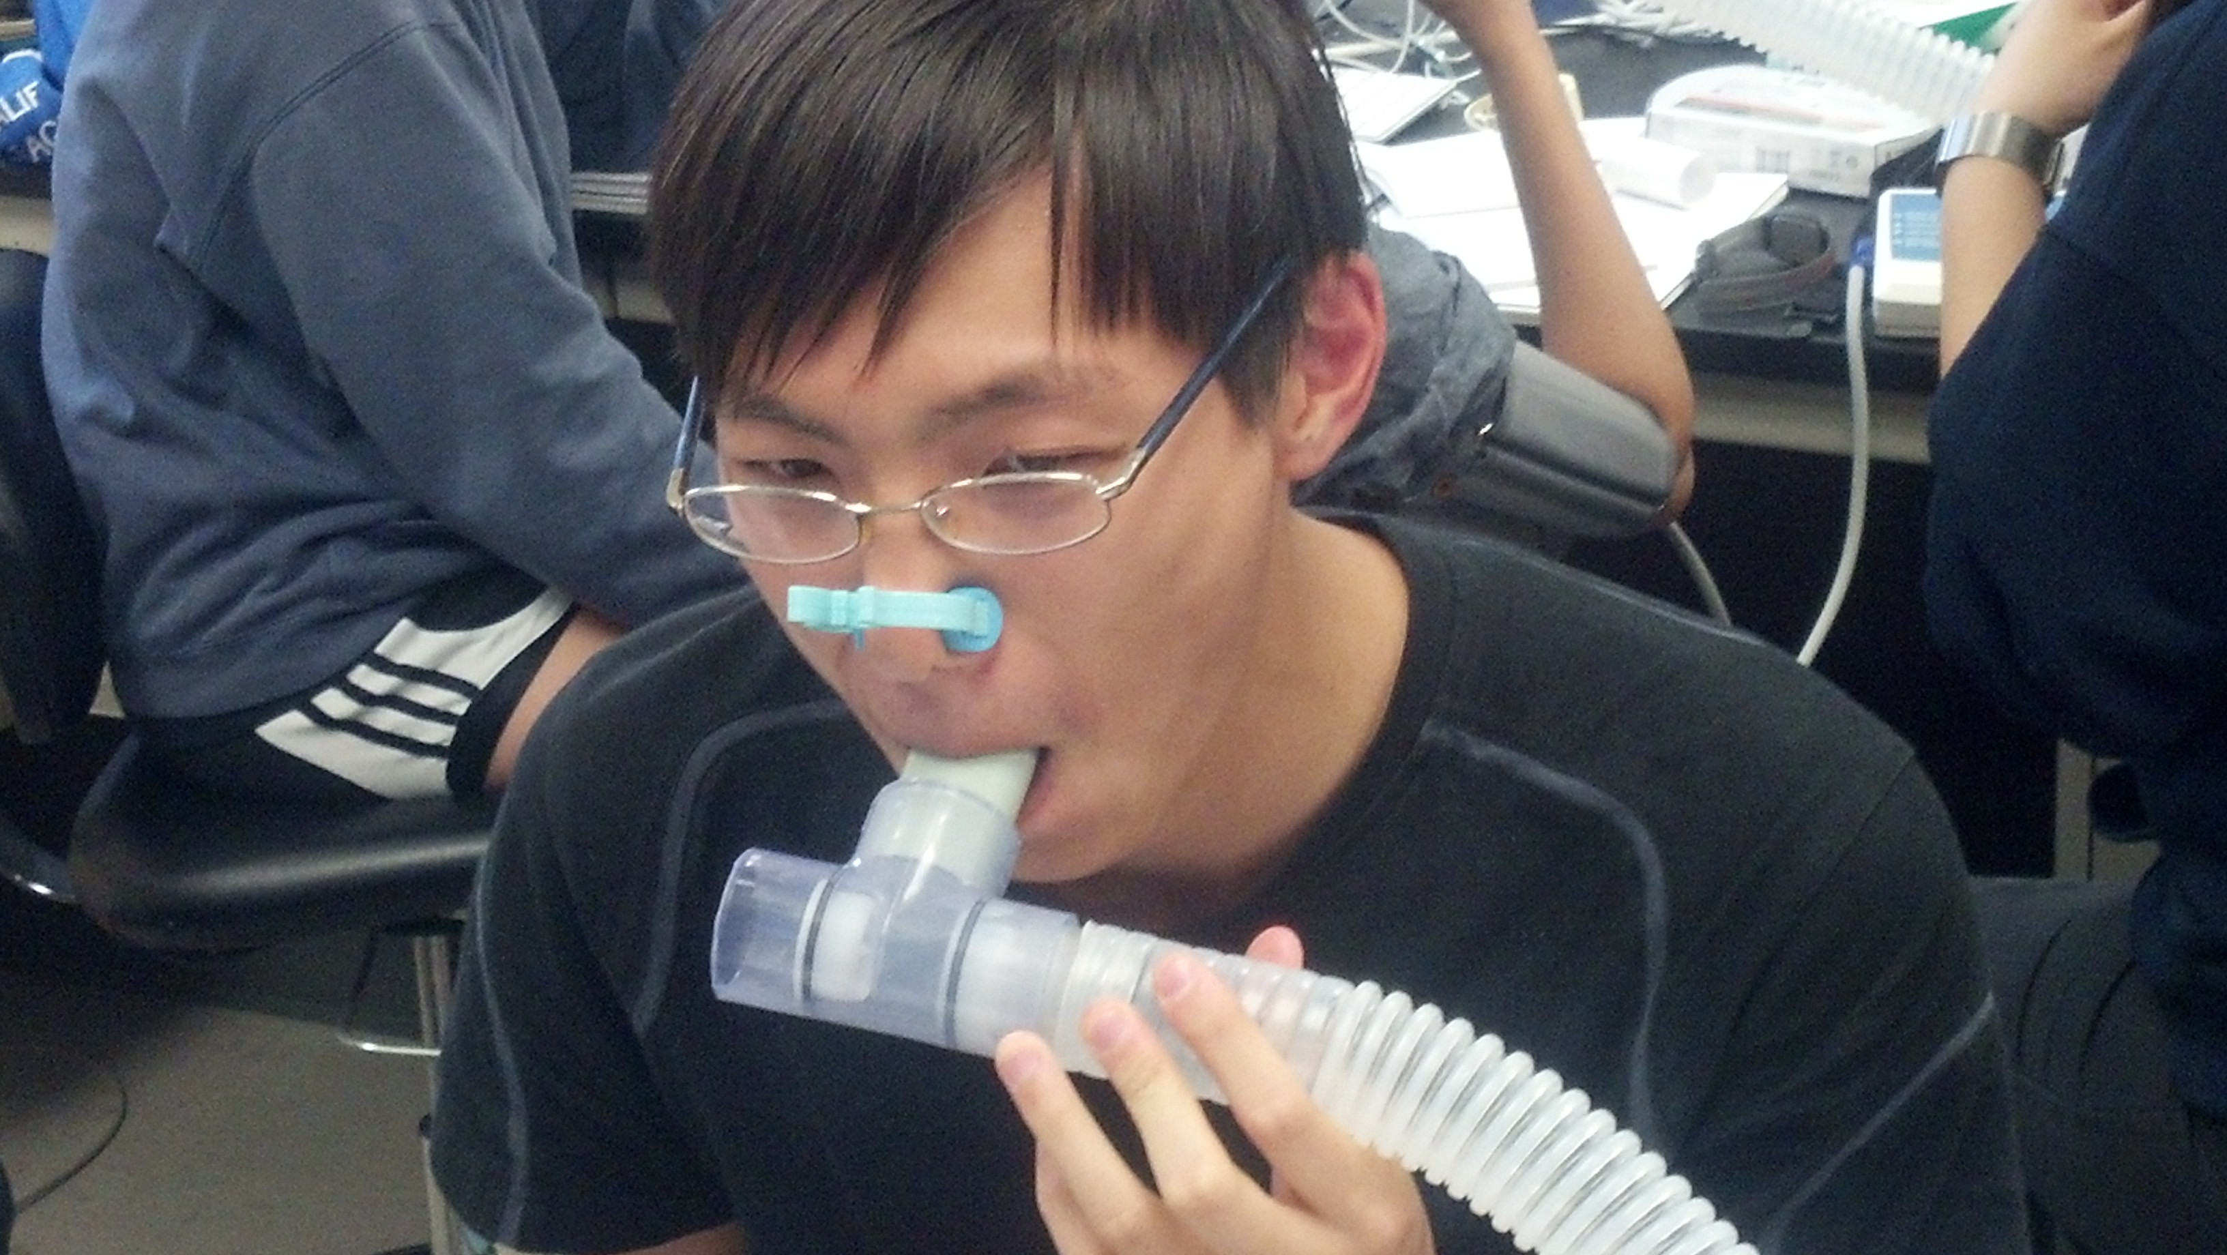

**One way air valves**

**Fresh air**

**Fig 2** Set-up for gas exchange analyzer

If the %O2 and %CO2 values are off, then you need to pump air into the chamber from the air hose line in the lab bench. Leave the program running while you do this and keep the air pumping in until the %O2 levels are greater than 20% and %CO2 levels are below 0.1%.

1. **Record data for another 20 secs with mouthpiece on the table and chamber closed.**
2. Keep the recording going. Prepare your subject by fitting a heart rate monitor around their chest and affixing the head gear/mouthpiece to the subject.  Use a noseclip so only air is breathed through the mouth.
3. Put mouthpiece in mouth and make sure you have a good seal around the mouthpiece (see Fig 2). Try to breathe evenly and calmly (heavy breathing will throw off data). It may feel like you’re not getting enough air, but the mouthpiece is open to the room air, so you can breathe normally. Make sure air is not coming out of the free end (it should be going into the tube).
4. Record resting data for at least 5 minutes before starting exercise (you should expect to see %O2 stabilize around 18% and %CO2 around 3%). The resting data will be used to calculate the basal metabolic rate, so make sure the subject is sitting and relaxed. See Figure 3 for a typical resting recording (you may want to zoom way out, so you can see the entire 5 minutes on the screen).
5. Use the heart rate monitor to record resting heart rate every 1 minute during the 5 minute rest period (enter in **Table 4**) and enter the steady state value in **Table 5**.
6. Stop the recording *before* telling the subject to stop breathing into the tube.
7. When you’re done with the recording, open the chamber again to allow any condensation to dry out. Always open the chamber when it is not in use. Remember to also use the air from the lab bench to clear out the chamber air. Your GSI can show you how to remove the tube from the back of the air chamber.
8. Using Labscribe, record the resting %O2, %CO2, Respiration Rate, VO2, VCO2, RER, and Ve in data **Table 5**. How to obtain each of these parameters is described below in the data analysis section.
9. After airing out the chamber, repeat step 1 to make sure the O2 and CO2 levels are back to normal.
10. Repeat steps 2 and 3.
11. Have your subject begin walking on the treadmill at a brisk pace (around 3-4 miles per hour). Again, try to breathe normally into the mouth piece. You will walk for about 5 minutes. You may need to do the experiment for longer than 5 minutes. Watch the data: when the %O2 and %CO2 have reached a steady state (i.e. a flat line), then continue the experiment for another 2 minutes.
12. Record the heart rate every minute during the 5 minute exercise period and enter in the **Table 4**. After 5 minutes of exercise use Labscribe to record the %O2, %CO2, Respiration Rate, VO2, VCO2, RER, and Ve and enter the values in **Table 5**.
13. Remember to stop the recordings *before* you tell the subject to stop breathing into the tube, so you have good data at the end of the recording.
14. Open the chamber again and air it out.

**Fig 3** Recording of CO2 and O2 during several minutes of breathing at rest. Note that CO2 levels start low and rise as the subject exhales more CO2. O2 levels decrease in the chamber as oxygen is consumed.

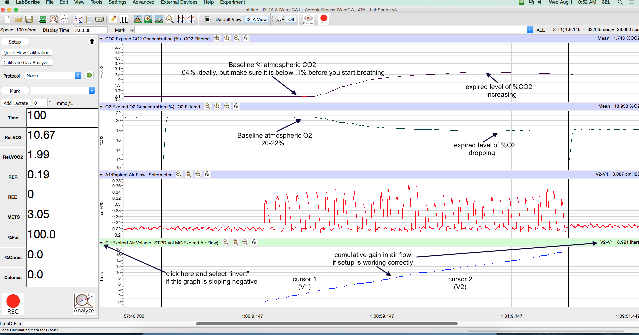

1. Repeat step 1 to check the O2 and CO2 levels. Repeat steps 2 and 3.
2. After collecting data at a walking pace, increase the pace to a challenging run (around 6 mph). The exact speed will be different for each student; it should feel like you are vigorously exercising. Try your best to breathe normally into the tubing, but this may be difficult.
3. Perform the same measurements for the run that you did for the walk and enter these values in **Table 4 and 5**.
4. Open the chamber again when you are done. Clear the air chamber out with the lab bench air, so it is the right O2 and CO2 levels for the next group.

**c) Data Analysis**The majority of the measurements from this exercise (all parameters except for heart rate) will be taken directly using the Labscribe software. Enter all the data in **Table 5**.

**Data collected directly from Labscribe graphs generated at rest or during exercise.**

The 3 parameters listed below (%O2, %CO2, Respiration Rate) will be one of the variables that are graphed on the screen as you collect data either at rest or during both exercises. You can obtain these data directly from the Labscribe plots.

%O2 = percent oxygen in chamber, which will be equal to %O2 in expired air when the graph gets to steady state. %O2 will be one of the variables measured directly with Labscribe and will be one of the graphs on the screen as you collect data either at rest or during exercise. Use the steady state value (when the graph flattens out).

%CO2 = percent carbon dioxide in chamber, which will be equal to %CO2 in expired air when the graph gets to steady state. %CO2 will be one of the variables measured directly with Labscribe and will be one of the graphs on the screen as you collect data either at rest or during exercise. Use the steady state value.

Respiratory rate = breaths/min, you will need to calculate this be measuring breath durations from Labscribe as you did in Lab 7. The respiration rate can be determined from the airflow plot, which is one of the graphs on the Labscribe screen.

Measure these parameters for at rest, during walking, and during running. Enter data in **Table 5**.

**Data collected using Offline Calculations.**1. First, you need to determine the % inspired O2 and % inspired CO2. You should use the %O2 and %CO2 values at the beginning of the resting experiment, before you began breathing into the chamber. These are the initial values in the chamber, so this is the way of “zeroing” the data, so each experiment starts at baseline. You can determine these values by using a single cursor and moving it to the start of the resting experiment before the subject started to breathe into the tube. Look at the values for %O2 and %CO2 at this cursor.

You will need to repeat this step for the beginning of all of your experiments, so make sure you always measure the initial %O2 and %CO2 values.

2. Look at your entire experiment and see when the %O2 and %CO2 were at steady state. You will be using the last minute of data to find the steady state average. If your data is not at a steady state at the end of the recording, your data will not be accurate. If something happened at the end of the recording so it was not steady, you can use the second to last minute of the recording to average.

3. Click the analyze button in the lower left of screen.

4. Click on the settings tab and enter the subject’s height and weight.

5. Enter the % inspired O2 and % inspired CO2 you measured in step 1.

6. Change Average (sec) to 60 seconds (this will average every minute of data).

7. Click calculate  
A table will appear which contains calculated data. Each row corresponds to 60 secs successive time points for your entire experiment. You want to use a row that corresponds to a steady state, so most groups will choose the last time point (the last minute of the recording) which is in the row above the mean. Write the value in **Table 5** for the following: VO2, VCO2, RER, Ve.

* VO2 = volume of oxygen consumed (liters of O2/min). Use the Abs VO2 value. Note that you will use this value at rest to calculate the basal metabolic rate.
* VCO2 = volume of carbon dioxide produced (liter of CO2/min).
* RER = Respiratory exchange ratio VCO2/VO2.  A value of 1 indicates the subject is burning 100% carbohydrates whereas a value of 0.7 indicates the subject is burning 100% fats.  Values in between are a ratio of carbohydrates and fat. This value will be calculated using offline calculations.
* Ve = minute ventilation, often measured in liters/minute.

8. Repeat this analysis for resting, walking and running data.

Name__________________________

**Lab 8: Exercise Physiology Worksheet**

|  |  |  |  |  |
| --- | --- | --- | --- | --- |
| **Table 1: Light Exercise** | | | | |
|  | **Exercise Period** | | **Post Exercise Period** | |
| Time | Heart Rate | Blood Pressure | Heart Rate | Blood Pressure |
| 30 sec |  | ---------- |  | --------- |
| 60 sec |  | ---------- |  | ---------- |
| 1:30 |  | ---------- |  | ---------- |
| 2 min |  | ---------- |  | ---------- |
| 3 min |  | ---------- |  | ---------- |
| 4 min |  | ---------- |  | ---------- |
| 5 min |  |  |  |  |

**II. BICYCLE ERGOMETER OR STEPS**

|  |  |  |  |  |
| --- | --- | --- | --- | --- |
| **Table 2: Moderate Exercise** | | | | |
|  | **Exercise Period** | | **Post Exercise Period** | |
| Time | Heart Rate | Blood Pressure | Heart Rate | Blood Pressure |
| 30 sec |  | ---------- |  | ---------- |
| 60 sec |  | ---------- |  | ---------- |
| 1:30 |  | ---------- |  | ---------- |
| 2 min |  | ---------- |  | ---------- |
| 3 min |  | ---------- |  | ---------- |
| 4 min |  | ---------- |  | ---------- |
| 5 min |  |  |  |  |

1) Summarize what happened to heart rate during exercise and after exercise. Explain why these changes occur.

**Table 3 – Calculations for bicycle or step exercise**

|  |  |  |  |  |  |  |  |  |
| --- | --- | --- | --- | --- | --- | --- | --- | --- |
|  | **Power output (Watts)** | **HR (beats/ min)** | **Ps (mmHg)** | **Pd (mmHg)** | **MAP (mmHg)** | **TPR (mmHg/ ml/sec)** | **SV (ml)** | **CO (ml/min)** |
| **Resting** |  |  |  |  |  |  |  |  |
| **Light resistance** |  |  |  |  |  |  |  |  |
| **Moderate resistance** |  |  |  |  |  |  |  |  |

2) Discuss how blood pressure, total peripheral resistance, stroke volume and cardiac output changed as exercise became more intense. Did you expect these kinds of changes? Explain the changes using physiology.

|  |  |  |  |
| --- | --- | --- | --- |
| **Heart Rate** | **Resting** | **Walking** | **Running** |
| initial |  |  |  |
| 1 min |  |  |  |
| 2 min |  |  |  |
| 3 min |  |  |  |
| 4 min |  |  |  |
| 5 min |  |  |  |

**III. TREADMILL**

**Table 4 – Heart rate changes during treadmill exercise**

|  |  |  |  |  |
| --- | --- | --- | --- | --- |
| **Parameter** | | **Resting** | **Walking** | **Running** |
| Heart Rate  (beats/min) | measured |  |  |  |
| % Oxygen | measured |  |  |  |
| % Carbon Dioxide | measured |  |  |  |
| Respiratory Rate (breaths/min) | measured from airflow |  |  |  |
| VO2 (L/min) | calculated |  |  |  |
| VCO2 (L/min) | calculated |  |  |  |
| RER | calculated |  |  |  |
| Ve (L/min) | calculated |  |  |  |

**Table 5 – Calculations for treadmill exercise**

3) Using the resting VO2 value, calculate the basal metabolic rate (BMR). Convert liters of oxygen consumed/min to Calories of heat produced per hour, assuming that 1L of O2 at STPD (standard temperature and pressure) produces 4.825 Cal. The conversion factor 4.825 is an estimate assuming the subject is oxidizing a mixture of carbohydrates and fats. Show your work.

Calories of heat/hour _____________

Calories of heat/day (BMR) _____________

4) If you assume that you consume 2000 Calories per day how does that compare to your resting metabolic rate that you calculated (measured in Calories/day)?  What factors would contribute to an incorrect measurement of your basal metabolic rate?

5) Explain what happened to %O2 and %CO2 levels in the chamber as exercise intensity increased. Why?

6) How did the RER vary as you increased the intensity of exercise?  What does this indicate about the type of fuel (carbohydrate or fats) that you are burning? How do you think the RER value varies if you just drank a sugary soda versus if you had fasted for 6 hours?

7) What are two ways our data collection for the treadmill experiment could be improved to be more accurate?